WeServe Project Report

Tholkappian Chidambaram#1, Venkatesh Devale#2,Sasank Matavalam#3, Matthew Zhu#4

*Software Engineering Department, San Jose State University  
1 Washington Square, San Jose, CA*

1tholkappian.chidambaram@sjsu.edu

2venkatesh.devale@sjsu.edu

3sasank.matavalam@sjsu.edu

4matthew.zhu@sjsu.edu

***Abstract* — This document gives a brief idea about the ‘WeServe’ Project implemented in the Spring 2018. This project is about matching the NGOs to the volunteers and pro-bono consultants based on their projects using machine learning.**

***Keywords*** — **NGO, Volunteer, Pro-Bono Consultant, Machine Learning, Node.JS, MySQL, ReactJS**

1. Introduction

Community and social projects are undertaken by various entities as part of the legal and humanitarian obligations. Community projects cover a wide variety of domains across many different regions. Managing different parties involved in these projects while fulfilling the legal requirements is a difficult task. Community projects also need to advertise the need for volunteers, reach out to community, optimal management of resources within the required timeline. Community projects may also be implemented at different regions with different set of parties but the process requirements are similar.

1. Problem Statement

In general the community projects does not have a platform to streamline the various stages of the project from start to finish. Projects lack resources to have a technology platform and apply best practices. Project managers or pro-bono consultants start out with paper based systems to collect data and make decisions. These projects also need help with consulting, outreach, collaboration, efficiency and applying proven techniques. Having a dedicated platform to support the community projects will enable the project to reach more people and will result in better social outcomes.

1. *Proposal*

We are proposing to build a web portal called WeServe with capabilities to support the community projects. WeServe will specifically address the problems faced by the persona in the previous section. This portal will facilitate initial posting and hiring workflow for the community projects. Volunteers, NGO representatives and pro-bono consultants can work on the projects and participate in the hiring workflow according to their role. WeServe will also recommend specific projects to a volunteer and a specific volunteer for a project manager. Recommendation of the projects and volunteers will be based on a weighted score computed by a set of volunteer’s attributes mentioned below.

* Location
* WeServe project navigation pattern
* Interests

1. *Scope*

WeServe portal will provide a basic framework for the proposal mentioned in the previous section. Portal is scoped specifically to help with initial stages of the community project and limited to hiring workflow. Portal will not support the following features but provides a framework to extend in future.

1. Ongoing collaboration of the community project with volunteers and stakeholders.
2. Specific area for community projects.
3. Keyword search specific individual or a project.
4. Web based forms instead of paper forms.
5. Project and volunteer data analytics.
6. *User Persona*

Community projects involve many different entities like Non-Governmental Organization (NGO), pro-bono consultants, volunteers, NGO representative, and government personnel. Some of the key project persona we observed are given below.

1. Vetrivel Foundation, *NGO*

*Bio:* Primary mission of Vetrivel Foundation is to bridge the digital divide in education that exists between remote villages, impoverished regions and those who have access to modern educational tools.

*Goals:*

* Empowering children by providing education.
* Decrease illiteracy in the world.
* Bridge the digital divide in education.

*Frustrations:*

* Unable to find volunteers.
* Need grass-root organizers to implement project.

1. Ram Kumar, *Student*

*Bio:* Ram is a student of Visual Communications in Pune, Maharashtra. He is cheerful, enthusiastic and always willing to help. He has been helping at a local school for a long time. Due to time constraint, he feels working with NGO projects will have greater reach and better utilization of his time.

*Goals:*

* Volunteer in social projects.
* Be a positive change in the society.
* Help the underprivileged.

*Frustrations:*

* Unable to find good projects.
* Resource and time constraint.
* Cannot find a good team to work with.

1. Implementation

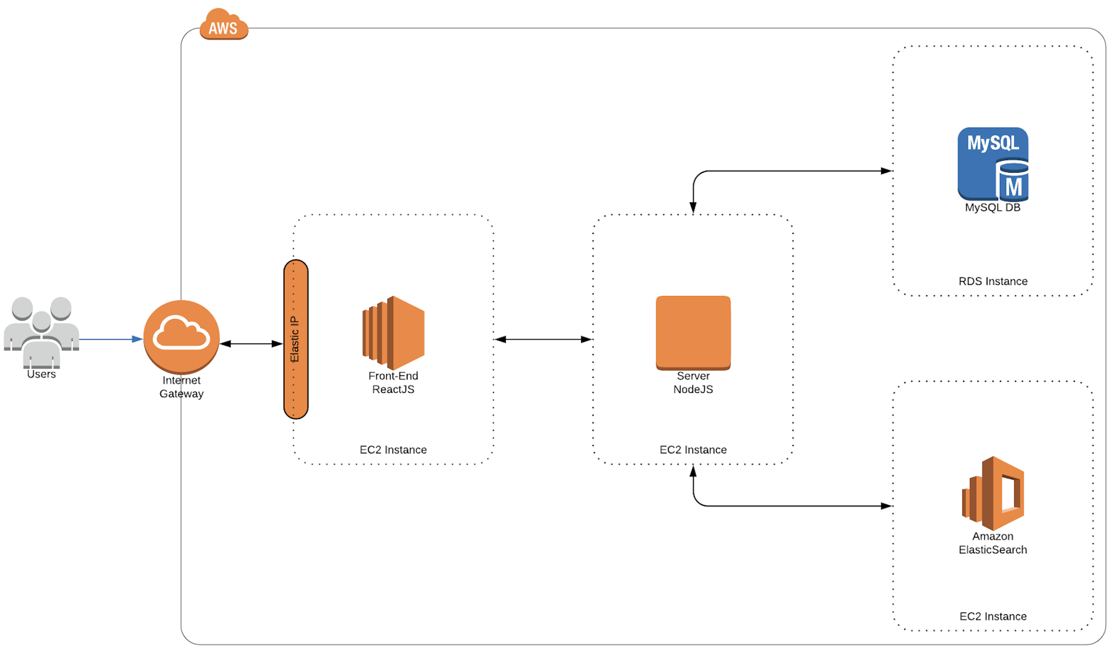

We reviewed the technology and literature for WeServe platform under the following components.

1. *Web Front-End*

We reviewed bootstrap so that we can get the design of the web front-end very attractive. We implemented the front-end in ReactJS.

ReactJS gave us the easier approach as we build custom components that we could use everywhere in the project. It was fast in rendering as it renders only the changed DOM and not the entire page itself.

It also helped us build the project as just a single page application.

1. *Back-End*

For the backend we have used Node.JS as our server side framework as Node.JS runs on a single thread and is a light weight process and also the request ,response methodology is relatively faster when compared to other server side frameworks.

Node.JS gives us a great library base that we can use with just importing the required modules not worrying about how they work at backend. We have used Bcrypt, express-sessions to name a few.

1. *Database*

We have used MySQL database as our datasource. We used this for two reasons as we wanted relational entities mapped. For example, NGOs to Volunteers and vice versa.

MySQL also gave us advantage of easy and faster readability. We used AWS RDS to host our MySQL database.

1. *ElasticSearch*

Recommendation is a machine learning model that is based on the concept of “wisdom of the crowd”. Recommendations are based on the assumption that if 2 volunteers share similar preferences or attributes then the things that one of them prefers could be good recommendation to make to the other. For example if volunteer A tends to like certain projects, and volunteer B shares some of the preferences with volunteer A, then the projects that the volunteer A liked, that volunteer B has not yet seen, may well be movies that volunteer B will also like.  
 Generation of recommendations is powered by Alternating Least Square algorithm. This algorithm solves a specific type of collaborative filtering model known as matrix factorization. A matrix representation of volunteer and project data is factorized to two smaller matrices each for volunteer and project.

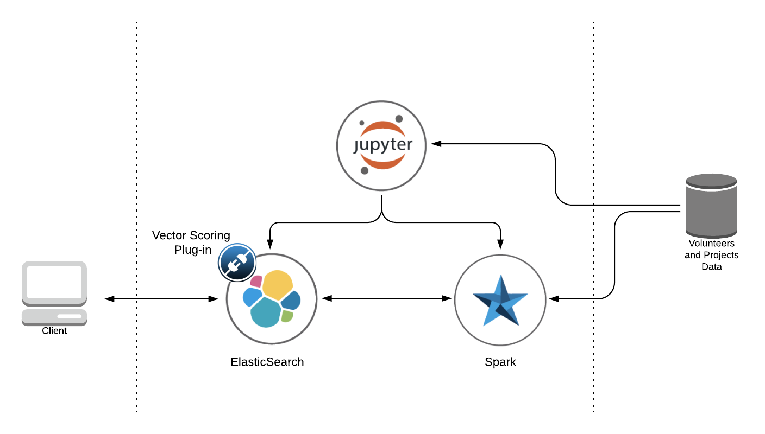

1. Conclusions

Project Artifacts

Following are the artifacts created for WeServe project.

- WeServe web platform, available at weserveyou.org  
- WeServe introductory video, available at   
 https://www.youtube.com/watch?v=BYRGomV1HDI  
- WeServe project code-base, available at

https://github.com/SJSU272LabSP18/Project-Team-13.  
- Project-volunteer recommendation model available within

the github project space.

References

1. “Apache Spark™ - Unified Analytics Engine for Big Data.” Apache Spark™ - Unified Analytics Engine for Big Data, spark.apache.org/.
2. IBM. “IBM/Elasticsearch-Spark-Recommender.” GitHub, github.com/IBM/elasticsearch-spark-recommender.
3. MLnick. “MLnick/Elasticsearch-Vector-Scoring.” GitHub, github.com/MLnick/elasticsearch-vector-scoring.
4. “Open Source Search &amp; Analytics · Elasticsearch.” Open Source Search &amp; Analytics · Elasticsearch, elasticsearch.org/.
5. “Project Jupyter.” Project Jupyter, jupyter.org/.
6. “Elasticdump.” Npm, www.npmjs.com/package/elasticdump.